A Final Year Project Report
Full Unit: Final Report

Project Title: Machine Learning Techniques for Predicting Product Demand in Retail Businesses
Miski Abdullahi Dahir
Ayan Bashir Hassan
A report submitted in part fulfilment of the degree of
BIT28 Information Technology
Supervisor:Ubaid Mohamed Dahir

Department of Information Technology
Faculty of computing, Simad University
August 2025

DECLARATION. A

We declare that the following is our own work and does not contain any unacknowledged work from any other sources. This project was undertaken to fulfill the requirements of the bachelor’s degree program in Information Technology at SIMAD University.

Name : ……………………………………………

Student Signature :………………………………….

Name :…………………………………………

Student Signature: ……………………………

Date : ……………………….……

DECLARATION. B

I hereby declare that the thesis entitled “Retail Demand Prediction Using Machine Learning” was carried out under my supervision at SIMAD University, Faculty of Computing. This work meets the academic and scientific integrity standards set by the institution.

The thesis presents a significant and practical contribution to the field of data science by applying advanced machine learning techniques to address a real-world challenge—predicting weekly retail demand using historical sales data. By utilizing ensemble models such as Random Forest and XGBoost, the research delivers a data-driven solution to improve inventory planning and operational efficiency in the retail sector.

The students have demonstrated strong technical skills, analytical thinking, and a clear commitment to leveraging artificial intelligence for solving industry-relevant problems. The research methodology is well-structured, the experiments are thorough, and the results highlight the real-world applicability of machine learning in demand forecasting.

I fully endorse this thesis for academic submission. To the best of my knowledge, this is an original piece of work and has not been submitted for any other academic or professional qualification.

ACKNOWLEDGEMENTS

Student One: Miski Abdullahi Dahir

I would like to express my heartfelt gratitude to my supervisor, Mr. Ubaid, for his continuous guidance, support, and insightful advice throughout the development of this thesis. His mentorship not only deepened my understanding of deep learning and its real-world applications particularly in the field of workplace safety but also inspired me to approach the subject with both curiosity and purpose.

I am also thankful to the Faculty of Computing at SIMAD University for providing a supportive academic environment, as well as to my teachers and fellow students, whose input and encouragement contributed meaningfully to the success of this project

Student Two: Ayan Bashir Hassan
I am deeply grateful to my supervisor, Mr. Ubaid, from the Faculty of Computing at SIMAD University, for his patience, guidance, and valuable feedback throughout this research. His expertise in machine learning and artificial intelligence laid a strong foundation for my work on retail demand prediction using ensemble models.
I would also like to express my sincere appreciation to my fellow students and faculty members for their continuous support and encouragement, which made this academic journey both enriching and rewarding.

ABSTRACT

Accurate demand forecasting is vital for retail businesses seeking to optimize inventory, enhance supply chain efficiency, and maximize profitability. Traditional forecasting methods, such as time series models, often fall short in today’s dynamic market environment where consumer behavior is influenced by complex and rapidly changing factors like seasonality, promotions, and economic shifts. This study investigates the effectiveness of machine learning techniques—specifically Random Forest and XGBoost—in forecasting weekly product demand using a real-world dataset from Nike retail sales across multiple U.S. regions.

The results show that machine learning models, particularly a tuned Random Forest, outperform basic models by capturing hidden patterns in the data and adapting well to unseen conditions. Key contributions include building a scalable prediction pipeline and highlighting the value of hyperparameter tuning and residual analysis for model evaluation.

Future research could enhance forecasting accuracy by incorporating external factors, exploring advanced models like LSTM, and applying the system to different brands or regions. This study confirms that machine learning significantly improves demand forecasting in retail environments.

TABLE OF CONTENTS
DECLARATION. A 1
DECLARATION. B 2
ACKNOWLEDGEMENTS 3
ABSTRACT 4
LIST OF TABLES 8
LIST OF FIGURES 8
LIST OF ABBREVIATIONS AND SYMBOLS 9
CHAPTER ONE 10
INTRODUCTION 10
1.2 Background 11
1.3 Problem Statement 12
1.4 Objectives of Project 13
1.5 Scope and limitation 13
1.6 Significance of the Study 14
1.7 Structure of the project 14
CHAPTER TWO 16
RELATED WORKS 16
2.1 Introduction 16
2.2 Related Works 17
2.3 Comparison with existing research 19
2.4 Relation to the General body of Literature 20
2.5 Summary of the Literature Review 22
CHAPTER THREE 24
RESEARCH METHODOLOGY 24
3.1 INTRODUCTION 24
3.2 Data Collection: 26
3.3 Data Description 26
3.3.1 Target variable 27
3.4 Data Preprocessing 28
3.4.1 Handling missing data 28
3.4.2 Outlier Detection 28
3.4.3 Feature selection 29
3.4.4 Encoding Categorical variables 30
3.5 Model selection and training 31
3.5.1 Train-Test Split 33
3.6 Performance Measurement 33
3.6.1 Mean Absolute Error (MAE) 34
3.6.2 Mean Squared Error (MSE) 34
3.6.3 R-Squared (R²) Score 34
3.7 Summary 35
CHAPTER FOUR 36
RESULTS AND DISCUSSION 36
4.1 Introduction 36
4.2 Performance Metrics Used 36
4.3 Experimental Results 37
4.4 Models Used and Comparison 40
4.5 Hyperparameter Tuning 42
Effect of Tuning 42
Visualization of Predictions 43
4.6 Error Analysis 47
4.6.1 Residual Plot 48
4.6.2 Histogram of Residuals 49
4.7 Interpretation of Results 50
4.7.1 Alignment with Project Objectives 50
4.7.2 Comparative Model Insights 51
4.7.3 Implications for the Dataset and Problem 52
4.7.4 Why Certain Models Performed Better 53
4.8 Limitations 53
4.9 Summary 54
CHAPTER FIVE 56
Conclusion and Future Work 56
5.1 Conclusion 56
5.2 Contributions 56
5.3 Future Work 58
REFERENCE 60

LIST OF TABLES
Table 2.1: Summary of Related Works on Machine Learning Techniques for Demand Forecasting
Table 3.1: Description of Dataset Features
able 4.1: Performance Comparison of Regression Models on Test Set
Table 4.4.1: Performance Comparison of Regression Models
Table 4.5.1: Performance Comparison Before and After Hyperparameter Tuning

LIST OF FIGURES
Figure 3.1.1: Retail Demand Forecasting Workflow
Figure 4.1: RMSE Comparison of Models on Training and Testing Sets
Figure 4.5.1: Sales Forecast Using Default Random Forest Model
Figure 4.5.2: Sales Forecast Using Tuned Random Forest Model
Figure 4.6.1: Residual Plot of Predicted Sales vs. Residuals
Figure 4.6.2: Histogram of Residuals for the Tuned Random Forest Model

LIST OF ABBREVIATIONS AND SYMBOLS
Abbreviation / Symbol | Meaning
SARIMA | Seasonal Autoregressive Integrated Moving Average
LSTM | Long Short-Term Memory
ETR | Extra Trees Regressor
SVM | Support Vector Machine
RMSE | Root Mean Squared Error
R² | R-squared (Coefficient of Determination)
MAE | Mean Absolute Error
MSE | Mean Squared Error
cv | Cross-validation
RF | Random Forest
XGBoost | Extreme Gradient Boosting

CHAPTER ONE

INTRODUCTION
1.1 INTRODUCTION
Retail companies benefit greatly from demand forecasting since it helps them anticipate consumer demand, improve inventory levels, and boost profits. Accurate forecasting decreases the risk of overstocking and understocking, which can lead to financial losses. Time series analysis and other traditional forecasting techniques frequently struggle to keep up with the rapid shifts in consumer behavior, particularly in the rapidly evolving retail industry of today. Factors such as seasonal trends, promotions, and economic issues impact demand patterns even more, making traditional methods less reliable. As deep learning and machine learning technology advance, new opportunities to increase forecasting accuracy arise. Machine learning outperforms traditional techniques in analyzing large data sets, uncovering hidden patterns, and identifying emerging trends.Retailers may increase supply chain efficiency, improve consumer happiness, and streamline their decision-making processes by implementing these cutting-edge strategies.

1.2 Background
Demand forecasting is an important part of retail business performance, directly affecting inventory management, supply chain efficiency, and customer satisfaction. Traditional forecasting methods, which rely mostly on past sales data, often struggle to keep up with the rapidly changing and unpredictable nature of retail markets today. These methods, such time series analysis , believe that future Sales will follow the same patterns as the past. However , this approach may not work well when there are sudden changes in consumer behavior or outside factors. For example, traditional methods had trouble predicting the high demand for face masks during the COVID-19 pandemic because past sales data never showed a sudden or unexpected event. As a result, businesses using traditional forecasting methods had problems with managing inventory and supply chain disruptions, showing the limits of depending only on past sales data. Latest advancements in machine learning and deep learning have created new opportunities to make demand forecasting models more accurate and reliable.
In the clothing and fashion industry , for example, Giri and Chen highlight the challenges created by the quick change of product life cycles, unpredictable market demand, and seasonal trends. Their suggested solution combines features of clothing images with past sales data , leveraging ML and DL techniques to predict future demand. This approach displays the potential of adding nontraditional data like product images into forecasting models to create a more complete way of making predictions (Giri & Chen, 2022).

Likewise, Mitra et al. emphasize the importance of advanced ML techniques in retail environments with multiple sales channels. Their comparison of regression models, including Random Forest, XGBoost, and ANN, shows that a combined model (RF XGBoost LR) works better than traditional methods. This finding underlines the value of combining multiple ML algorithms to improve forecasting accuracy, especially in environments where various data sources and complex interactions must be considered (Mitra et al., 2022).

Anitha and Neelakandan (2024) address the challenge of forecasting demand for new fashion products, where past sales are often missing or hard to get. Their suggested model uses K-means and decision tree classification to learn customers preferences based on room fitting data. By grouping customer profiles and predicting demand for new products, this method helps retailers to match inventory to customers preferences, reducing extra stocking and improving profit. This model reveals the application of unsupervised learning techniques to better understand and forecast demand when there is not enough past data available (Anitha & Neelakandan, 2024).
Generally, these research studies underscore the transformative potential of ML and DL techniques in retail demand forecasting. Retailers can produce forecasting models that are more accurate and dependable by integrating data from several sources, such as product photos, consumer preferences, and sophisticated machine learning algorithms. This study supports my project's goals, which center on how machine learning approaches might enhance demand forecasting in retail establishments. The lessons we have acquired from previous investigations will inform the methodology and application of machine learning models in this project.

1.3 Problem Statement
Demand forecasting remains challenging despite advancements in machine learning, particularly for retail organizations with a wide range of products and varying client behavior. In contemporary retail, When demand is influenced by different factors such as seasonal trends, economic issues, promotional events, and sudden market changes, traditional techniques struggle to provide accurate predictions. This problem can cause poor inventory management, overstocking, or lost sales opportunities. This study explores how machine learning techniques can improve demand forecasting by finding patterns in sales data and adjusting to changing market conditions. The goal is to bridge the gap between traditional forecasting methods and advanced data-driven approaches to improve prediction accuracy and support better decision-making.

1.4 Objectives of Project

The objectives of this research study are as follows:

- To explore the use of machine learning techniques to predict demand in retail businesses.
- To balance different machine learning models, such as tree-based algorithms, deep learning models, and ensemble approaches, to decide the most accurate forecasting method for retail demand.
- To use a dataset (Nike Sales data) from different U.S. regions to estimate the performance of these models over different market conditions.

1.5 Scope and limitation
This study employs machine learning approaches to estimate demand for retail enterprises. Specifically, it analyzes a Nike sales dataset, which is a two-year record that includes data from several U.S. locations. Since this study only looks at Nike products, its findings might only apply to retail fashion, footwear, and apparel companies rather than all industries. Since the dataset focuses on the U.S., the Findings may not be applicable to retail enterprises of other countries due to differing consumer behavior and economic conditions. This study compares different machine learning models but excludes external factors like economic growth, supply chain issues, and sudden demand change.

1.6 Significance of the Study
This research is crucial because it improves demand forecasting accuracy in retail businesses, especially in the fashion and clothing industry. By applying machine learning techniques to a various dataset of Nike sales data, this study will give retailers reliable tools to predict demand, improve inventory, and reduce waste.
The findings are most relevant to fashion and footwear retail businesses as they share comparable sales trends, seasonal trends, and customer behavior. Machine learning techniques used may also apply to other retail industries. This study demonstrates how machine learning outperforms traditional methods in demand forecasting, providing insights to help retail businesses improve decision-making, customer satisfaction, and profitability.

1.7 Structure of the project
The structure of this project follows:
- Chapter 1: provides Introduction introduction to the research topic ,including the problem statement, objectives, scope, limitation, and significance of the study, setting the foundation for the entire research and highlighting the need for improved demand forecasting methods in the retail market.
- Chapter 2: presents a comprehensive literature review, exploring existing research on various demand forecasting models and techniques, with a specific focus on machine learning approaches, while also identifying gaps in literature that this study aims to fill, emphasizing the limitations of traditional forecasting methods.
- Chapter 3: Outlines the research methodology, detailing the processes of data collection, preprocessing, and machine learning models employed for demand forecasting, ensuring clear understanding of the technical approach and maintaining the choice of models based on their suitability for retail demand forecasting.
- Chapter 4: The results of demand forecasting are presented and discussed , comparing their performance and analyzing their potential impact on retail businesses, offering useful ideas about how well these models work.
- Chapter 5: Concludes the study by summarizing key findings and providing recommendations for retail businesses on how to effectively utilize machine learning techniques in demand forecasting to improve decision-making, enhance operational efficiency, and stay competitive in the market while suggesting potential future research directions to improve these forecasting methods even more.

CHAPTER TWO

RELATED WORKS

2.1 Introduction

Demand forecasting is a crucial component of retail enterprises because it helps them anticipate client demand, enhance inventory control, and boost overall profitability. Although they have been widely employed, traditional forecasting techniques like statistical models and time series analysis have failed to identify shifting demand trends. Authors have looked into many methods to increase forecast accuracy as machine learning (ML) has advanced, which will assist retailers in making informed decisions.
This chapter connects different models, methodology, and their findings in recent studies to examine the literature on machine learning techniques in demand forecasting.The review looks at how many writers approach demand forecasting, the advantages and disadvantages of their approaches, and the research gaps that my study attempts to fill. This study's objective is to situate itself within a broader field of study and emphasise what makes it distinct and special.

2.2 Related Works

Demand forecasting has seen a significant transformation in recent years, moving from conventional techniques to more sophisticated statistical machine learning approaches.These adjustments were discussed by both Falatouri et al. (2022) and Shakir and Modupe (2023). Falatouri et al. (2022)'s research work compares SARIMA with LSTM models, while Shakir and Modupe (2023) discuss different machine learning regressors. Both of these writers highlight how machine learning may improve demand forecasting accuracy. Similarly, Nasseri et al. (2023) and Pavlyshenko (2019) investigated the potential of machine learning models, particularly ensemble approaches and deep learning to improve the accuracy of sales forecasting. Meanwhile, Anitha and Neelakandan (2024) and Nassibi et al. (2023) highlighted how machine learning can significantly reduce waste and increase profit by improving demand forecasting and inventory management. Nasseri et al. (2023) contrasted tree-based ensembles (ETRs) with LSTM, and Pavlyshenko (2019) focused on stacking techniques, which combine predictions from multiple models to improve accuracy.

Additionally, each of these studies has its own set of difficulties and restrictions. For instance, Falatouri et al. (2022)'s study focuses on a single Austrian shop and a certain category of goods, thus, important things like replacing products and new products taking sales from old ones are missing. Further, the study's failure to differentiate between low sales due to customers not wanting the product or it being out of stock is a problem because the author solely concentrated on models rather than adding other criteria. The authors Shakir and Modupe (2023), may not be able to apply their findings generally because they only examined a tiny dataset from a single logistics company in Brazil.Only ERTs and deep learning learning models were included in the Nasseri et al. (2023) study, which limited the ability to comprehend other ideal casting methods. Anitha and Neelakandan (2024)'s study is centred on a single store, and
fails to consider strategies like mobile apps and internet shopping. This limits demand forecasting, as it doesn’t gather customer data about what they browse , purchase and look for online.

The areas of dispute in these many studies are presented. In their research, Nasseri et al. (2023) discovered that the ERT model outperformed the LSTM model. Falatouri et al. (2022) pointed out that the LSTM model works best for products with steady demand because it can recall past data, which helps predict trends over time. SARIMA, on the other hand, works well for products that perform well in seasonal patterns, such as winter clothing or holiday snacks. These differing viewpoints highlight how crucial it is to understand the kind of data you have before selecting a forecasting model. In contrast to merely averaging the predictions, Pavlyshenko (2019) supports stacking, a technique that combines predictions from various models using a different model (meta model). Nasseri et al. (2023) focused mostly on Extra Tree Regressors (ETRs) but also investigated ensemble approaches.

The authors discuss the several research gaps that require attention. Falatouri et al. (2022) suggested that since these variables can affect consumer demand, future studies should take into account outside variables including weather, calendar events, and the availability of comparable products. According to Nassibi et al. (2023)'s research, demand forecasting models ought to incorporate sales promotions as an independent feature. Falatouri et al. (2022) also suggests combining the SARIMA(X) and LSTM models to improve store level sales forecasting. More studies comparing tree based ensembles with deep learning models over short, medium, and long term forecasting horizons are encouraged by Nasseri. Also, a more varied dataset is needed covering different regions, product types and sales channels, to make demand forecasting models more accurate and applicable in different situations. Many research studies reviewed focus on specific stores or limited areas, which make it harder to apply in other situations or in general. Finally, experts and customers' opinions when there is no good past data to be reliable with the extra information can improve the prediction made by machine learning.

2.3 Comparison with existing research
Many research papers have involved on demand forecasting using machine learning , but most of them is using data from specific and limited sources. For example , Anitha and Neelakandan (2024) carry out research on demand forecasting in one specific store in Tamil Nadu. In parallel ,Shakir and Modupe (2023) focused on logistic company in Brazil , and other research studies inspect particular markets like perishable food products in Saudi Arabia. These research studies give valuable information but their study scope is limited to one industry, region or business type.

Instead of concentrating on a particular business or store, my research article uses machine learning approaches for demand forecasting, which sets it apart with its large dataset and more diverse reach. Nike Sales, which includes transactions outside of several U.S. areas during a two-year period, will be the dataset I use. This information will enable us to examine patterns across many locations and store kinds, broadening the scope of my research in contrast to earlier studies that focus on a specific company or market.

2.4 Relation to the General body of Literature

In general , the literature review of demand forecasting emphasizes the importance of machine learning techniques for improving accuracy. Research studies have shown that tree based models, deep learning and ensemble methods can perform better than traditional forecasting techniques. Also , many studies focus on external factors like seasonality, promotions, and customer liking, in enhancing demand predictions. This study fits with other research papers by using machine learning to analyze real sales data. However, this study contributes to a widely recognized brand with sales over multiple regions. Furthermore, this wider view will help us understand how demand forecasting models work in a more complex retail environment.
Table 2.1: Summary of Related Works on Machine Learning Techniques for Demand Forecasting
Authors | Focus | Methods used | Key findings | Criticisms/Limitations
Falatouri et al. (2022). | Comparing SARIMA and LSTM for Retail demand forecasting. | SARIMA and LSTM. | Machine learning (LSTM) improves forecasting accuracy compared to traditional methods . | This paper focus only one store in Austria looks few items doesn’t consider product replacement, can not tell if product drop is due lower demand or stock shortage.
Shakir and Modupe (2023) | Enhancing Retail demand forecasting with machine learning regression | Different machine learning regressors | Machine learning enhnaces demand forecasting accuracy | Small dataset from a single logistics company in Brazil, limits generalisability.
Nasseri et al. (2023) | Tree based ensembles vs LSTM. | Tree based ensembles (ETRs), LSTM. | Ensemble methods and deep learning improve sales forecasting | Focus on ETRs and deep learning models limits understanding of other potential models, may not apply universally.
Pavlyshenko (2019) | Stacking techniques in sales forecasting | Stacking multiple models | Combining predictions of multiple models to improve accuracy | Limited focus on stacking techniques , may not generalize across all domains
Anitha and Neelakandan (2024) | Fshion demand forecasting | K-means clustering, Decision tree classification | Machine learning techniques improve demand forecasting by understanding customer preference | Based on a single store,excludes online and mobile channels, hasn’t been tested for future data accuracy
Nassibi et al. (2023) | Food demand forecasting (fruits & vegetables) | Support Vector Machine(SVM), long short term memory(LSTM) | LSTM outperformed SVM in demand forecasting accuracy | Focus on specific product (confectionery), may not generalise across all food products or sectors

2.5 Summary of the Literature Review

When compared to traditional statistical models, machine learning significantly improves the accuracy of demand forecasting, according to the study research we analysed in general. Researchers have examined a variety of approaches, including ensemble methods, SARIMA, and LSTM, with varying degrees of success depending on the dataset and business context. Numerous studies concentrate on predicting a single business or store; more extensive study that uses machine learning across various locations and items is required.
By integrating a variety of Nike sales data from outside the United States, my analysis closes this gap and improves our comprehension of demand trends. By doing this, it adds knowledge to the body of research that can benefit numerous retail businesses, not just one company or store.

CHAPTER THREE

RESEARCH METHODOLOGY

3.1 INTRODUCTION
This chapter explains the process we used to develop a machine learning model to forecast future sales for retail businesses. The aim is to avoid overstocking and understocking by forecasting the number of units sold from past sales data. This involves collecting and preprocessing past sales data, selecting the appropriate features, and employing machine learning models to generate accurate predictions. Various preprocessing techniques such as missing values, categorical variables, and data normalization were done to improve model performance. Various models were also trained and tested on corresponding metrics in order to determine the best method towards retail demand forecasting.
The methodology follows these steps:
1. Data Collection
2. Data Description
3. Data Preprocessing
4. Model Selection and Training
5. Performance Evaluation
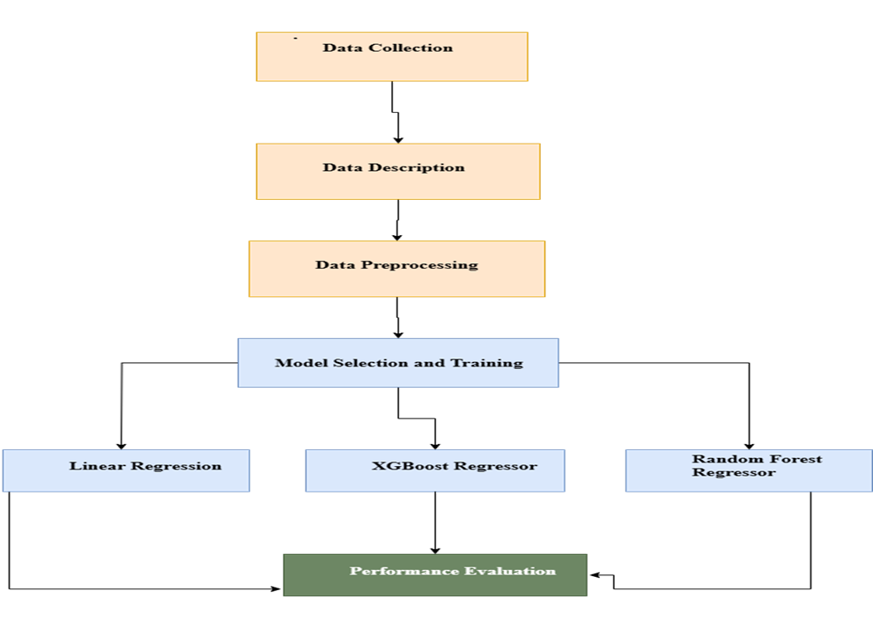
Figure 3.1: Retail Demand Forecasting Workflow

3.2 Data Collection:
The data consists of Nike sales transactions with details about products, retailers, regions, sales methods, and prices.We gathered the data from a nike’s retail sales system, likely over a period of time (from January 2020 onwards based on the records available).

3.3 Data Description
- Total Records: The data consists of a total of 9,360 sales transactions made by an individual, with each being a singular record of a purchase transaction that took place within the covered period.
- Dataset Size: The entire dataset occupies 712KB of storage, making it concise yet extensive in thorough sales-related information.
- Time Period Covered: The range of data is from January 1, 2020, to December 31, 2021, a full two-year timeframe, which is appropriate for evaluating trends, seasonality, and changes in customer behavior over time.
- Features in the Dataset
Table 3.3: Summary of Dataset Features
Feature | Description
Invoice Date | The date when the sale was carried out.
Product | The category of the product (i.e., Men's Footwear, Women's Apparel).
Region | The location where the sale was carried out.
Retailer | The company selling the product
Sales method | Whether the sale was online or in-store
Price per Unit | The price of a single unit of the product.
Total Sales | The total revenue generated from the sale.
Units Sold | The target variable (the number of products sold)

3.3.1 Target variable
The purpose of this study is to predict "Units Sold," or the number of goods expected to be sold in the future. Effective Units Sold forecasting is critical to retailers as it will enable them to better manage inventory by keeping stock levels aligned with demand. It avoids both stockouts, in which sales are lost, and overstocking, in which money is wasted. With forecasts of Units Sold, retailers are able to minimize stock, reduce inefficiencies in operations, and make better purchasing, pricing, and staffing decisions.

3.4 Data Preprocessing
Before we trained the models, we cleaned and preprocessed data for accuracy. This includes handling missing values, encoding categorical variables, feature selection and outlier detecting . It also includes dividing the data into training and testing datasets, choosing appropriate models, training them, and assessing how well they are performing to make precise predictions. The following are steps we took:

3.4.1 Handling missing data
Before applying any of the machine learning models, we checked the dataset for missing values to ensure data consistency and integrity. Here, after deep investigation, it was determined that no missing data had been found across any of the columns. This ensured that our dataset was unbroken, thus enabling a proper and effective modeling process without having to impute or drop any data points.

3.4.2 Outlier Detection
Outliers in Price per Unit, Total Sales, and Units Sold were detected in our dataset using the IQR method. The outliers occurred in Men's and Women's Apparel of West Gear (Western region) with Price per Unit ranging between 90 and 100 and irregular sales values. These outliers can be explained by price mistakes, demand booms, or data mistakes.

3.4.3 Feature selection
Feature selection is necessary to prepare the dataset for the machine learning model. We established Invoice Date as a prominent feature for learning sales patterns over time in this study. Invoice Date was transformed to provide two new features that preserve important seasonal information:
· Year: The year was derived from the Invoice Date (i.e., 2020, 2021). This allows the model to consider yearly trends, e.g., changes in demand due to overall economic conditions or company-specific incidents.
· Month: The month was also extracted (e.g., January = 1, February = 2), so the model could identify monthly sales patterns. This is useful in capturing seasonality, for example, higher sales during holidays or special promotion periods.

The most relevant features for predicting sales were selected:
o Price per Unit
o Region (encoded as numbers)
o Product (encoded as numbers)
o Year
o Month
Therefore our target variable is Units Sold.
Through the transformation of these traits, the model is more capable of learning about the temporal nature of the sales data and, therefore, is enhanced at predicting future Units Sold by examining past trends.

3.4.4 Encoding Categorical variables
There are certain columns in the data, such as Product, Region, and Sales Method, with categorical variables in the form of text. Since machine learning models can only take numerical values to carry out the computation, categorical variables must be encoded in numerical form. To achieve this, One-Hot Encoding was used.
One-Hot Encoding takes every single unique category in a column and transforms it into its own separate binary (0 or 1) column. For example, the Product column might have different product categories like:
Men's Street Footwear
Men's athletic footwear
Women's apparel
Each unique product category gets a new column allocated to it (i.e., Product_Men's Street Footwear, Product_Men's Athletic Footwear, and Product_Women's Apparel). For each row of the data set, the corresponding product category receives a 1 in its corresponding column and 0 in all the others. This form of encoding allows the model to differentiate among product categories and learn how they influence the target variable, Units Sold, without subjecting it to any ordinal or numerical bias.

3.5 Model selection and training
Three different machine learning models were used to predict units sold; these models were selected based on their strengths in modelling different kinds of data:
Random Forest Regressor is a more complex tree-based model that generates a forest of many decision trees. Through overfitting minimisation and generalisation maximisation, it enhances forecast accuracy by identifying complicated correlations and non-linear patterns in the data.
XGBoost Regressor: A powerful boosting algorithm that builds a series of trees one after another. XGBoost enhances the model's performance by focusing on the previous tree's errors, thereby being very effective at improving prediction accuracy and handling large, complex data sets.

RANDOM FOREST (Punia et al.2020) also introduced a hybrid model
using Long Short-Term Memory (LSTM) networks and Random Forest. While LSTM
learns sequential patterns in data, Random Forest forecasts the difference (or
the residuals) of the LSTM predictions. With both approaches combined, accuracy
improves, especially when dealing with sudden impacts of holidays and
promotions. (Mitra et al., 2022)
Random Forest would be well-suited to our project as it is
very capable of detecting non-linear patterns and abrupt shocks to retail
demand. The flexibility of the model to capture steep spikes or drops is
crucial in giving a reliable prediction of demand, especially in retail where
one-off events and seasonal sales exert strong impact. Furthermore, its
robustness against overfitting and feature importance flexibility make it an
excellent choice for improving our forecasting accuracy.
XGBOOST MODEL Using a variety of features, including
pricing, product attributes, sales data, and promotional activities, XGBoost
has been successfully used to forecast retail demand. The intricate, non-linear
correlations between historical sales and future demand can be captured by
XGBoost by combining time-lagged sales data, seasonality factors, and other
temporal aspects. This methodology has been effective in the retail industry in
spotting patterns and forecasting outcomes, which has helped companies make
better supply chain and inventory management choices. XGBoost is a flexible
tool for demand forecasting since it can be tailored to various retail
scenarios and factors, enabling firms to tailor the model to their particular
requirements. (Mitra et al., 2022)
In our project, XGBoost is highly suitable because it's
designed for handling complex, non-linear relationships in retail demand
forecasting. Its ability to handle temporal trends as well as sudden changes
(e.g., holiday peaks or promotions) is what makes it effective at improving
forecast accuracy. Additionally, the flexibility of XGBoost in parameter tuning
allows for better model optimization, thereby generating more stable demand
forecasts.

3.5.1 Train-Test Split
To make a proper estimation of the machine learning models' performance, the dataset was split into two parts:
80% Training Data: This portion of the dataset was used to train the models such that they are able to identify the underlying trends and correlations among the features and the target variable, Units Sold.
20% Test Data: The remaining 20% of the data was held in reserve for testing. This dataset was never used when training and gave a good indication of the ability of the models to generalize to new, unseen data, allowing one to verify how accurately the models were able to estimate sales in the future.
By splitting the data in this way, we ensured that the models were being properly trained while also evaluating their performance on data they had not been exposed to during the training process.

3.6 Performance Measurement
After we had trained the models, we assessed their performance by evaluating them on the held-out testing data. This helped us to know how well the models were able to predict Units Sold on unseen data. To quantify the accuracy of the models, we used the following performance measures:

3.6.1 Mean Absolute Error (MAE)
MAE estimates the average absolute difference between forecasted sales and actual sales. It gives an idea of how close the model's forecasts are to the actual values on average. Better model performance is indicated by lower MAE because it means that the forecasted values are closer to the actual sales values. It is an easy measure and is easy to interpret, so it is convenient when assessing model performance.

3.6.2 Mean Squared Error (MSE)
MSE approximates the squared differences between actual and predicted values and averages them. MSE is particularly responsive to large errors because the squared terms place more emphasis on large deviations. The lower the MSE, the better, as the model is making fewer large mistakes. MSE is useful if you'd like to penalize larger errors more harshly, which may be beneficial in order to enhance model performance.

3.6.3 R-Squared (R²) Score
The R² score measures the accuracy of the model in predicting the variation of the target variable (the sales in this case). It is the proportion of variance in the target that can be predicted by the model. The nearer the R² value to 1.0, the more the model is capable of explaining the variation in the data and producing highly accurate predictions. An ideal value of about 0 would show that the model is not correctly encoding the interrelations in the data.

3.7 Summary
This chapter presented the methodology for predicting future sales with machine learning. The data was preprocessed, with categorical variables encoded to improve model performance. Three models Linear Regression, Random Forest Regressor, and XGBoost Regressor were tested, with the Random Forest model providing the highest performance. This model will be utilized for forecasting future product demand, allowing retailers to make more knowledgeable inventory choices and improve overall business efficiency.

CHAPTER FOUR

RESULTS AND DISCUSSION

4.1 Introduction

The aim of this project was to develop a machine learning system to forecast weekly product demand (Units Sold) by studying historical Nike retail data. This chapter examines the utilised machine learning models, evaluates their performance, discusses insights gained from the trials, and addresses the models' limitations. It discusses the mechanics of hyperparameter optimisation and provides a brief error analysis to enhance model comprehension.

4.2 Performance Metrics Used

This is a regression problem; hence, the subsequent evaluation metrics were employed:

- Root Mean Squared Error (RMSE): Assesses the average size of deviation between forecasted and actual sales. Reduced values signify superior performance.

- R-squared (R² Score): Represents the fraction of variance in the target variable elucidated by the model. A number approaching 1 indicates a superior match.

These measures were selected due to their ability to balance accuracy measurement (R²) and error size (RMSE), which is crucial in forecasting activities.

4.3 Experimental Results

This section presents the results of the machine learning models developed to predict weekly retail sales. The assessment focuses on two primary regression metrics: Root Mean Squared Error (RMSE) and R² Score. These measurements enable us to assess the accuracy and utility of each model.

Three principal models were evaluated:

- XGBoost Regressor (the fundamental boosting model)

- Random Forest Regressor (the fundamental bagging model)

- Optimised Tuned Random Forest Regressor (utilising RandomizedSearchCV)

RandomizedSearchCV was employed to determine the appropriate hyperparameters for the Random Forest model, enhancing performance. Although cv=3 was established during the search, it was not employed to evaluate the model; it was solely utilised to enhance the training process.

The models were subsequently assessed using a distinct test set including 20% of the data to evaluate their generalisation capabilities.
Table 4.3: Performance Comparison of Regression Models on Test Set

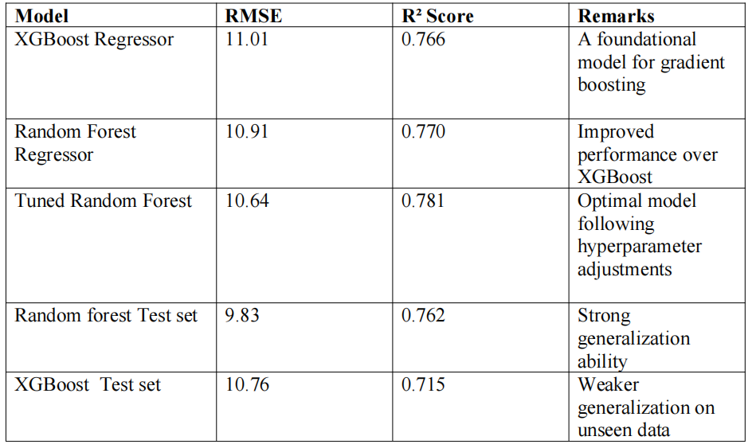

Figure 4.1 presents the RMSE values for each model as depicted in the bar chart. This graphical comparison clearly illustrates the performance disparities across the models. The modified random forest model exhibited the lowest RMSE throughout both training and testing, indicating superior predictive accuracy. The Random Forest model (test set) demonstrated excellent generalization ability, with an RMSE of 9.83. This outperformed the XGBoost model, which exhibited elevated error rates on unseen data (RMSE: 10.76). These results indicate that modifying the random forest enhanced its training efficacy while ensuring consistent performance on previously unseen data.

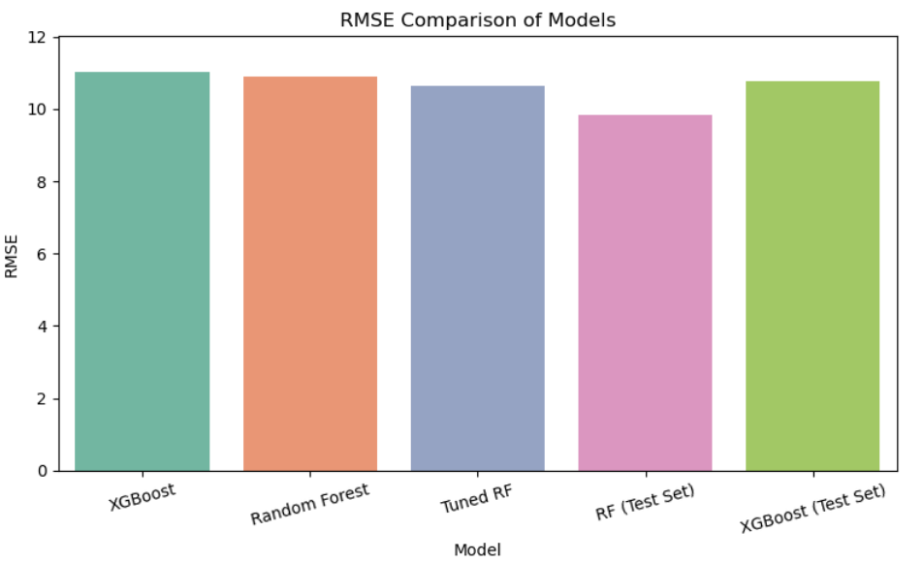
Figure 4.3: RMSE Comparison of Models on Training and Testing Sets

4.4 Models Used and Comparison

Three distinct regression models were developed for this project to utilise time-lagged factors from historical sales data to predict weekly retail unit sales. The following are the models:

- XGBoost Regressor: A gradient boosting method that sequentially constructs trees to minimise error. It is robust, however susceptible to overfitting.

- Random Forest Regressor (Baseline): An ensemble of decision trees that integrates multiple models trained on bootstrapped datasets. It is robust and comprehensible.

- Tuned Random Forest Regressor: The baseline Random Forest was enhanced by optimising its hyperparameters to increase accuracy and generalizability.
Table 4.4.1: Performance Comparison of Regression Models
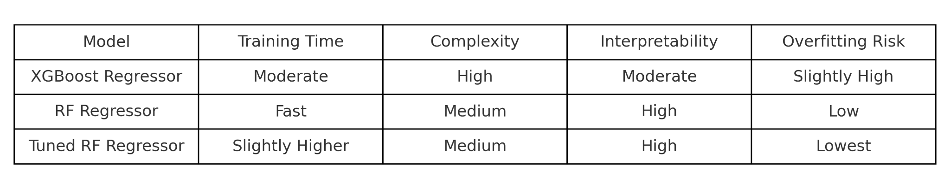
The Tuned Random Forest exhibits superior generality and overall accuracy in terms of performance. The subsequent stats were as follows:

- Root Mean Square Error: 10.64

- R² Score: 0.781

The XGBoost Regressor performed better on the training set but worse on the test set, indicating a degree of overfitting. The baseline Random Forest exhibited stability, although it lacked the accuracy achieved post-tuning.

4.5 Hyperparameter Tuning

RandomizedSearchCV was employed to optimize the hyperparameters of the baseline Random Forest model to enhance its performance. The objective of this method was to identify the optimal combination of parameter values to reduce model variation and improve generalization.

The subsequent hyperparameters were identified as yielding optimal results:
- n_estimators = 400
- max_depth = 20
- min_samples_split = 5
- max_features = 'log2'

Effect of Tuning
Table 4.5.1: Performance Comparison Before and After Hyperparameter Tuning
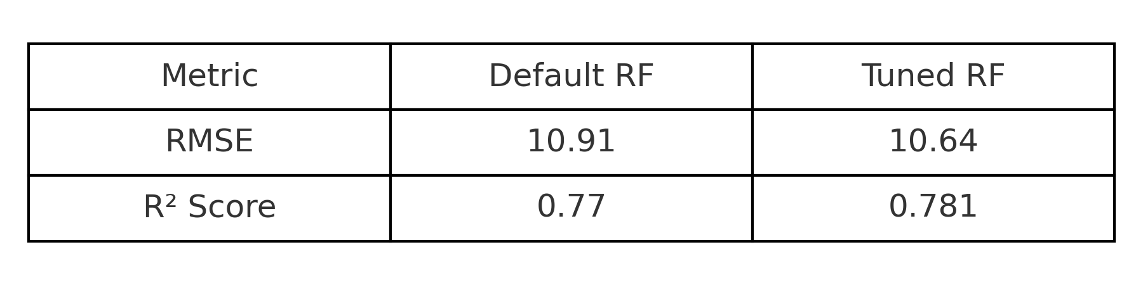
This indicates that the adjustments enabled the model to achieve a more optimal equilibrium between bias and variance.

Visualization of Predictions

A test scenario was conducted to demonstrate the effects of tuning, maintaining lag values at a constant 100 units, and stabilizing time-related inputs. The subsequent 4-week sales forecasts are presented below for both the default and optimized random forest models.

This figure presents the 4-week sales forecast using the default Random Forest model. The results show high fluctuation and sensitivity to input values.
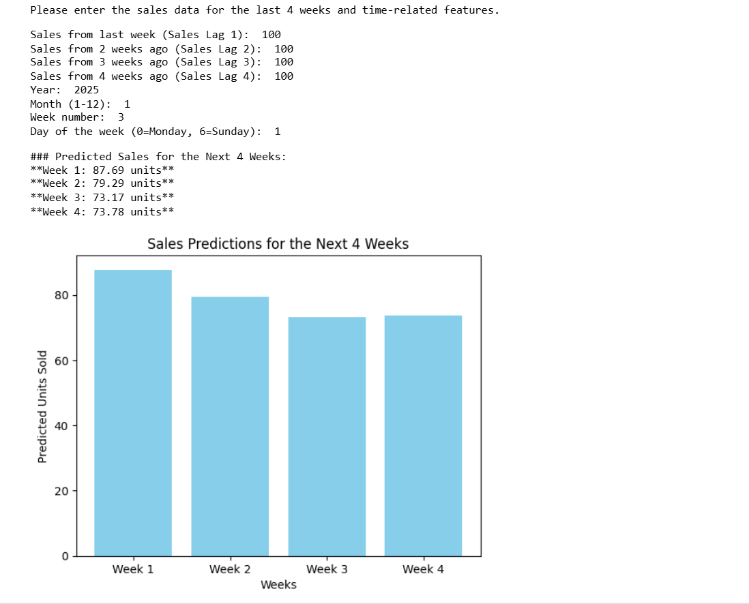
Figure 4.5.1: Predicted Sales Before Hyperparameter Tuning
Sales that are expected:

- Week 1: 87.69 units

- Week 2: 79.29 units

- Week 3: 73.17 units

- Week 4: 73.78 units

The forecasts indicate a significant decrease over time, characterized by substantial weekly changes, particularly between Week 1 and Week 3, with a reduction of approximately 14.5 units.

This indicates that the default model may be excessively responsive to input values, leading to less stable predictions.
This figure shows the improved 4-week sales forecast after tuning the Random Forest model, resulting in more stable and consistent predictions.
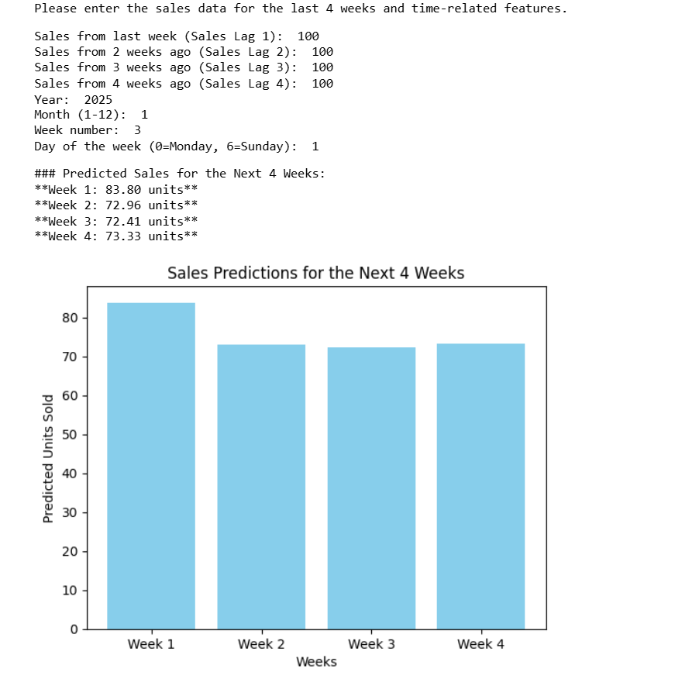
Figure 4.5.2: Predicted Sales After Hyperparameter Tuning

Predicted sales:

- 87.69 units during the initial week

- 79.29 units during the second week

- 73.17 units during the third week

- 73.78 units during the fourth week

The projections indicate a clear decline over time, accompanied by significant weekly variations. For instance, from Weeks 1 to 3, the quantity of units decreased by around 14.5.

This indicates that the default model may exhibit excessive sensitivity to input data, perhaps resulting in less stable predictions.

A test case was employed to demonstrate the functionality of tweaking. The lag values remained at 100 units, and the temporal inputs were stabilized. The sales projections for the forthcoming four weeks for both the standard and adjusted Random Forest models are presented here.

4.6 Error Analysis

error analysis was conducted utilising residuals, defined as the differences between actual sales values and predicted sales values, to evaluate the performance of the Tuned Random Forest model. Residual analysis facilitates the identification of model bias, overfitting, or underfitting.

4.6.1 Residual Plot

Figure 4.6.1 below illustrates the relationship between predicted sales and their corresponding residuals.
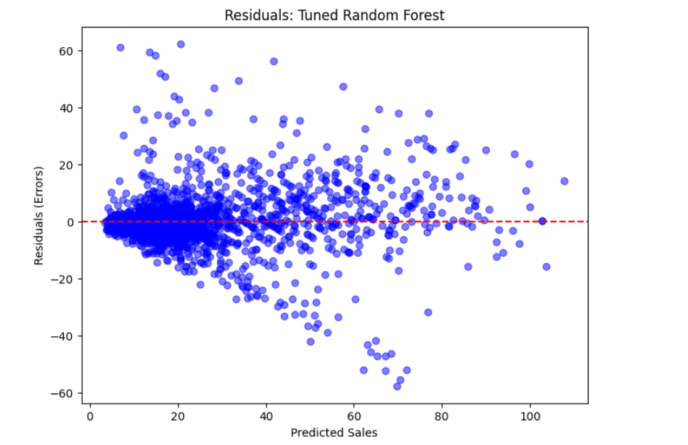
Figure 4.6.1: Residual Plot of Predicted Sales vs. Residuals

Observations:

- The residuals are distributed around the horizontal zero line, signifying that the model produces both overestimations and underestimations, without a discernible systematic error.

- The majority of the residuals are concentrated around zero, indicating a high level of predictive accuracy.

- A subtle funnel shape is observed, as the dispersion of residuals escalates with elevated expected sales, suggesting a potential mild heteroscedasticity (non-constant error variance).

4.6.2 Histogram of Residuals

Figure 4.6.2 shows the histogram of residuals, which provides insight into the distribution and frequency of the prediction errors.

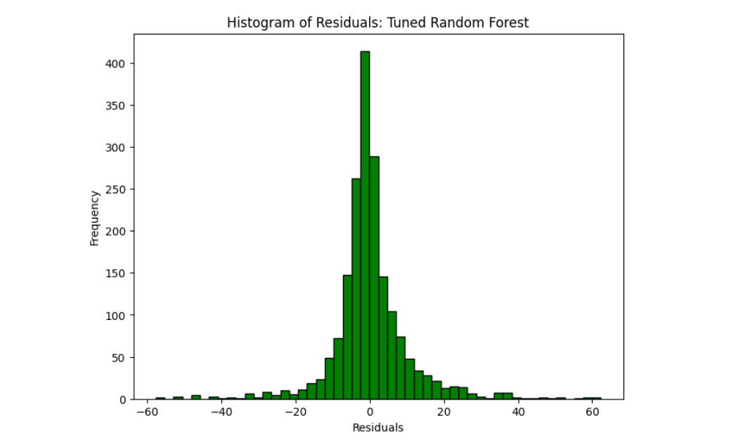
Figure 4.6.2: Histogram of Residuals for the Tuned Random Forest Model

Observations:

- The residuals have an approximate normal distribution, centred at zero. This is a favourable result in regression models.

- The bulk of residuals are within the interval of -20 to +20, signifying that most predictions are around the actual values.

- The histogram indicates that the model has minimal bias, with no discernible skewness in either direction.

- A number of outliers are evident on both extremes, as is anticipated in empirical datasets.

4.7 Interpretation of Results

This section links the experimental outcomes to the primary objectives of the research. It evaluates model performances, clarifies the causes of disparities, and derives conclusions concerning the dataset and forecasting objective.

4.7.1 Alignment with Project Objectives

The objectives of this project were

- To investigate the application of machine learning for demand forecasting in retail establishments.

- To achieve the most precise predictions, it is essential to integrate various machine learning models, including tree-based algorithms, deep learning architectures, and ensemble methods.

- To evaluate performance using a real-world dataset (Nike Sales Data) from various U.S. locales.

We achieved these objectives by developing, modifying, and evaluating three distinct regression models (XGBoost, Random Forest, and Tuned Random Forest) utilizing a weekly retail sales dataset.

4.7.2 Comparative Model Insights

The following models were tested:

- The tuned Random Forest Regressor had the best test performance (RMSE: 10.64, R²: 0.781), which was a good balance between accuracy and generalizability.

- Random Baseline The forest was stable but not quite as precise.

- The XGBoost Regressor did well during training, but it wasn't as accurate on the test set, which means it might have overfit.

These results show that tree-based ensemble models are quite good for predicting retail demand, especially when the hyperparameters are set correctly. Random Forest is great for sales data that looks like time series data since it is strong against noise and overfitting.

4.7.3 Implications for the Dataset and Problem

The analysis indicates that

- Using tree-based models with sales data from the past is a solid technique to guess how much retail sales will be.

- Models like Random Forest may be able to learn from the Nike sales dataset because it has tendencies that happen at specific periods of the year or day.

- Some heteroscedasticity (shown in the residuals) and outliers indicate how sales work in the real world. This is most likely due to marketing, regional trends, or special events that aren't in the dataset.

- The fact that the residuals are spread out quite typically is a good sign for the model's health because it means that the mistakes are primarily random and not biased.

4.7.4 Why Certain Models Performed Better

The tuned random forest model outperformed others for several reasons:

- Hyperparameter modification facilitated an improved equilibrium between bias and variance.

- The ensemble architecture of the model mitigates the risk of overfitting while effectively capturing intricate relationships within the data.

- When not properly adjusted, XGBoost may overfit; yet, Random Forest demonstrates superior stability in generalization performance across test samples.

4.8 Limitations

This study encountered specific issues that may have influenced the outcomes, despite appearing favorable.

- Restricted Feature Set: The dataset for this study mostly comprised historical sales data. Significant external factors such as sales, seasonal events, competitive pricing, or economic indicators were omitted. The omitted elements could significantly influence sales predictions.

- Model Interpretability: Tree-based models, such as Random Forest, are more comprehensible than fundamental linear regression methods, despite still being classified as black-box models. This complicates the acquisition of valuable business insights from each forecast.

- Computational Limitations: RandomizedSearchCV proved beneficial for hyperparameter optimisation; nevertheless, it was restricted to a limited search space and incurred substantial costs. A more comprehensive grid search or an expanded random search space may yield superior models.

- Overfitting in Boosting Models: The XGBoost model exhibited overfitting, performing effectively on the training data but poorly on the test set. This indicates that the model may have acquired noise from the training dataset rather than discernible patterns applicable in other contexts.

- Generalisation Beyond the Dataset Scope: The model was developed utilizing historical sales data from Nike in specific regions of the United States. The results may not be applicable to other brands, markets, or regions without additional modifications.

4.9 Summary

This chapter went into a lot of depth about how to create, test, and assess different machine learning models that can forecast how much demand there will be for retail. The models were XGBoost, a simple Random Forest, and a Tuned Random Forest Regressor.

The evaluation, which employed RMSE and R² values, showed that the Tuned Random Forest did the greatest job of generalising, with an RMSE of 10.64 and a R² score of 0.781 on the test data.

Residual analysis indicated that the model's predictions were predominantly unbiased and regularly distributed. The majority of the residuals ranged from -20 to +20. This made folks even more sure that it was safe.

There were a lot of concerns, too, mainly with feature availability and compute capacity, even though the performance was good. These issues show where things could be better.

This builds up the last chapter, which will finish the study and recommend new areas for research.

CHAPTER FIVE

Conclusion and Future Work

5.1 Conclusion
This study evaluated the application of machine learning techniques to forecast weekly product demand using Nike retail sales data. The objective of the study was to identify the most effective forecasting model among ensemble methods such as Random Forest and XGBoost.

The findings indicate that machine learning algorithms, particularly the Tuned Random Forest, can precisely forecast retail demand. It can generalize to previously unseen data and yield normally distributed residuals, rendering it an excellent option for real-world retail forecasting.

The experiment demonstrates how hyperparameter optimization and model selection can enhance forecast accuracy.

5.2 Contributions

- Created a machine learning pipeline that uses past data to predict retail sales.

- Used industry-standard regression metrics to look at and evaluate several models.

- Showed that tuning makes models better at generalizing.

- Emphasized the application of residual analysis for comprehending model efficacy.

- Provided a proof-of-concept that can be applied to additional retail datasets or enterprises.

5.3 Future Work

To augment and expand this research, the following directions are proposed:

- Incorporating Attributes
This study just employed historical sales data. Incorporating external factors such as holidays, sales, weather, and regional economic conditions might enhance the accuracy of future predictions.

- Methods for Comprehending a Model
In the future, explainable AI methodologies like SHAP (SHapley Additive exPlanations) may be employed to gain insights into the model's prediction processes. This can enhance organizations trust in the outcomes and enable them to act with greater confidence.

- Diverse Models
Consider exploring deep learning models such as LSTM (Long Short-Term Memory), which are effective for time series data. Integrating traditional and machine learning techniques in a hybrid model may enhance performance.

- Automated Forecasting System
Employing the optimal model in a real-time system enables shops to forecast demand without manual data entry. This would enhance the model's use for routine company operations.

- Evaluation Across Various Brands or Regions
The model can be evaluated on alternative retail brands or in diverse global regions to assess its efficacy in varying contexts. This would demonstrate the model's applicability across various contexts and its versatility.

REFERENCE
- Giri, C., & Chen, Y. (2022). Deep Learning for Demand Forecasting in the Fashion and Apparel Retail Industry. Forecasting, 4(2), Article 2. https://doi.org/10.3390/forecast4020031
- Anitha, S., & Neelakandan, R. (2024). A Demand Forecasting Model Leveraging Machine Learning to Decode Customer Preferences for New Fashion Products. Complexity, 2024(1), 8425058. https://doi.org/10.1155/2024/8425058https://doi.org/10.3390/data4010015

- Mitra, A., Jain, A., Kishore, A., & Kumar, P. (2022). A Comparative Study of Demand Forecasting Models for a Multi-Channel Retail Company: A Novel Hybrid Machine Learning Approach. Operations Research Forum, 3(4), 58. https://doi.org/10.1007/s43069-022-00166-4
- Falatouri, T., Darbanian, F., Brandtner, P., & Udokwu, C. (2022). Predictive Analytics for Demand Forecasting – A Comparison of SARIMA and LSTM in Retail SCM. Procedia Computer Science, 200, 993–1003. https://doi.org/10.1016/j.procs.2022.01.298
- Shakir, T., & Modupe, A. (2023). Enhancing demand forecasting in retail supply chains: A machine learning regression approach. Global Journal of Management and Business Research, 23(A8), 1–15. Retrieved from https://journalofbusiness.org/index.php/GJMBR/article/view/102919

- Nasseri, M., Falatouri, T., Brandtner, P., & Darbanian, F. (2023). Applying Machine Learning in Retail Demand Prediction—A Comparison of Tree-Based Ensembles and Long Short-Term Memory-Based Deep Learning. Applied Sciences, 13(19), Article 19. https://doi.org/10.3390/app131911112

- Pavlyshenko, B. M. (2019). Machine-Learning Models for Sales Time Series Forecasting. Data, 4(1), Article 1. https://doi.org/10.3390/data4010015

- Nassibi, N., Fasihuddin, H., & Hsairi, L. (2023). Demand Forecasting Models for Food Industry by Utilizing Machine Learning Approaches. International Journal of Advanced Computer Science and Applications (IJACSA), 14(3), Article 3. https://doi.org/10.14569/IJACSA.2023.01403101(Lindfors, n.d.)
- Lindfors, A. (n.d.). (2021) . Demand Forecasting in Retail: A Comparison of Time Series Analysis and Machine Learning Models.
- Mitra, A., Jain, A., Kishore, A., & Kumar, P. (2022). A Comparative Study of Demand Forecasting Models for a Multi-Channel Retail Company: A Novel Hybrid Machine Learning Approach. Operations Research Forum, 3(4), 58. https://doi.org/10.1007/s43069-022-00166-

